Saskatoon Lake Agricultural Society

Winter 2023
We are pleased to welcome Sue Tegart and Tammy Manning to the SLAS Board! 2023 will see an active Hall so don't forget to check our Facebook, Twitter and website for updates on Hall happenings and events. Thank you for your continued support and we look forward to a busy 2023.

Free Family Day Pancake Breakfast (donations appreciated)
February 20th, 9-11 a.m. cribbage tournament 9:30-10:30 am $10 adult $5 youth buy in
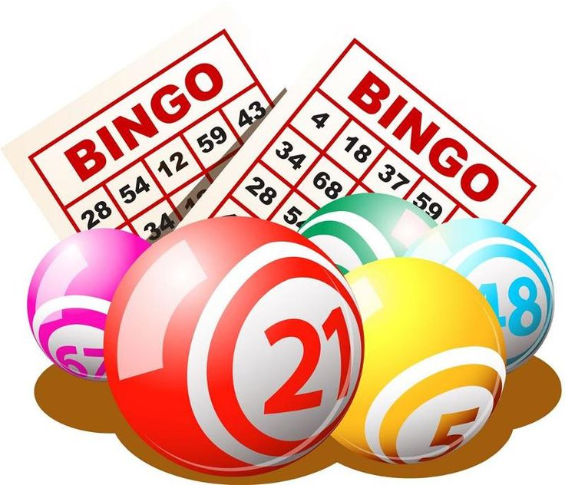
Family Friendly BINGO Nights
January 14, February 11th, March 4th, April 22nd
Doors open 5 p.m. Games start 6 p.m. Concession open
Free Family Movie Nights
January 27th, February 24th, March 17th, April 7th
Doors open 5:30 p.m. Movie starts 6 p.m. Concession open
SLAS Spring Fling
April 1st, Doors open 5:30, Supper @ 6pm. Contact us or a Board Member for your tickets.

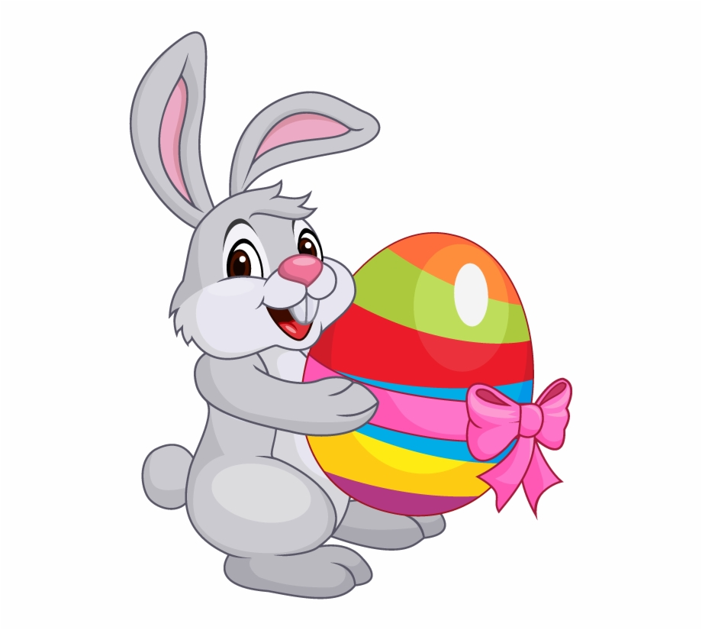
EGGciting Easter
2pm April 7th, $2 admission. Join us for egg painting, planting & games then stay to watch the Free Family Movie at 6pm!

Ladies Night
February 25th - activity to be announced, stay tuned for details!

Scan for Events Calendar

Stay up to date with everything SLAS
saskatoonlakeagsociety@gmail.com
Facebook: @SLAShall
Twitter: @SaskLakeHall
saskatoonlakecommunityhall.weebly.com

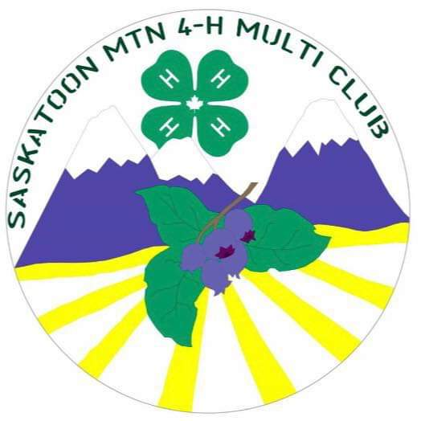
This coupon is good for one (1) free MEAL DEAL per family at a Free Family Movie Night at the Saskatoon Lake Community Hall.

Good for January 27th, February 24th, March 17th, April 7th.

Available for all your hair needs

Open Wednesday – Saturday

Please call for an appointment
780-766-3400

